TOWERS OF HANOI

AIM: To implement a prolog program to implement Towers of Hanoi.

OBJECTIVES:
- To implement the Towers of Hanoi problem using recursion in Prolog and generate the sequence of moves required to transfer all disks from one peg to another..

ALGORITHM:
- Start with N disks on the source peg.
- If there is only one disk, move it directly from source to destination.
- Otherwise, Move N-1 disks from source to auxiliary peg or Move the largest disk from source to destination or Move N-1 disks from auxiliary peg to destination.
- Continue recursively until all disks are moved.
- Display every move.

SYSTEM-ARCHITECTURE:


PROGRAM:
% TOWERS OF HANOI

hanoi(1, From, To, _) :-
write('Move disk from '),
write(From),
write(' to '),
write(To),
nl.

hanoi(N, From, To, Aux) :-
N > 1,
M is N - 1,

hanoi(M, From, Aux, To),

write('Move disk from '),
write(From),
write(' to '),
write(To),
nl,

hanoi(M, Aux, To, From).

OUTPUT:
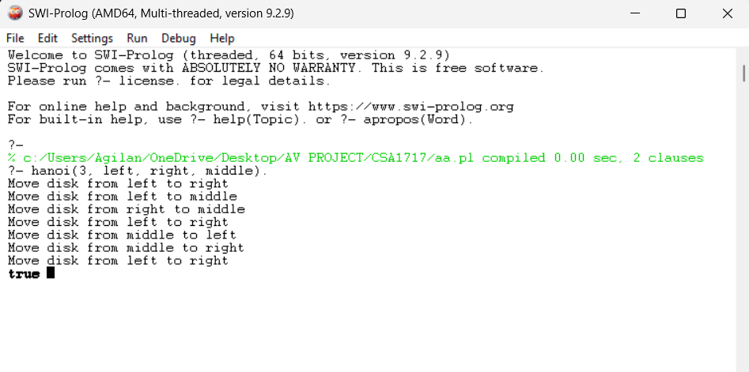

RESULT: Thus the Tower of Hanoi is implemented successfully using Prolog program.

